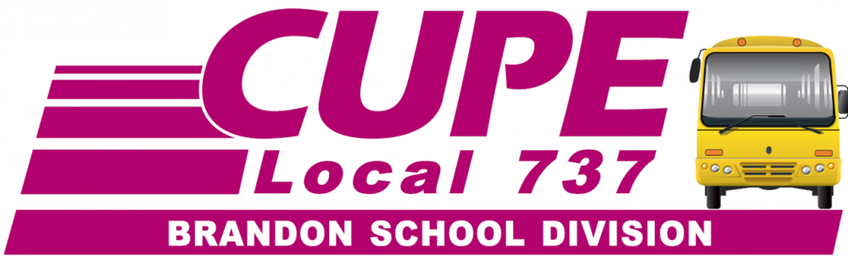
SUPPORT STAFF – COME TO YOUR NEXT
MONTHLY MEETING
WEDNESDAY OCT. 10/2018
at 7:00 P.M.
Brandon Union Office - 1911 Park Avenue
- Long Service Recognition – October 10th, 6:00 pm, come out for refreshments and visit with your past co-workers. Meeting to follow at 7:00.

- BTA and CUPE are holding a Trustee Forum on October 11th, 7:00 pm at the Victoria Inn Salon 1. On October 24th we vote for our bosses.

- CUPE Local 737 Monthly General Meeting is on the second Wednesday of each month (except January, July and August).

